Creativity is the Currency
for the 21st Century

Thomas More College
Crestview Hills, KY

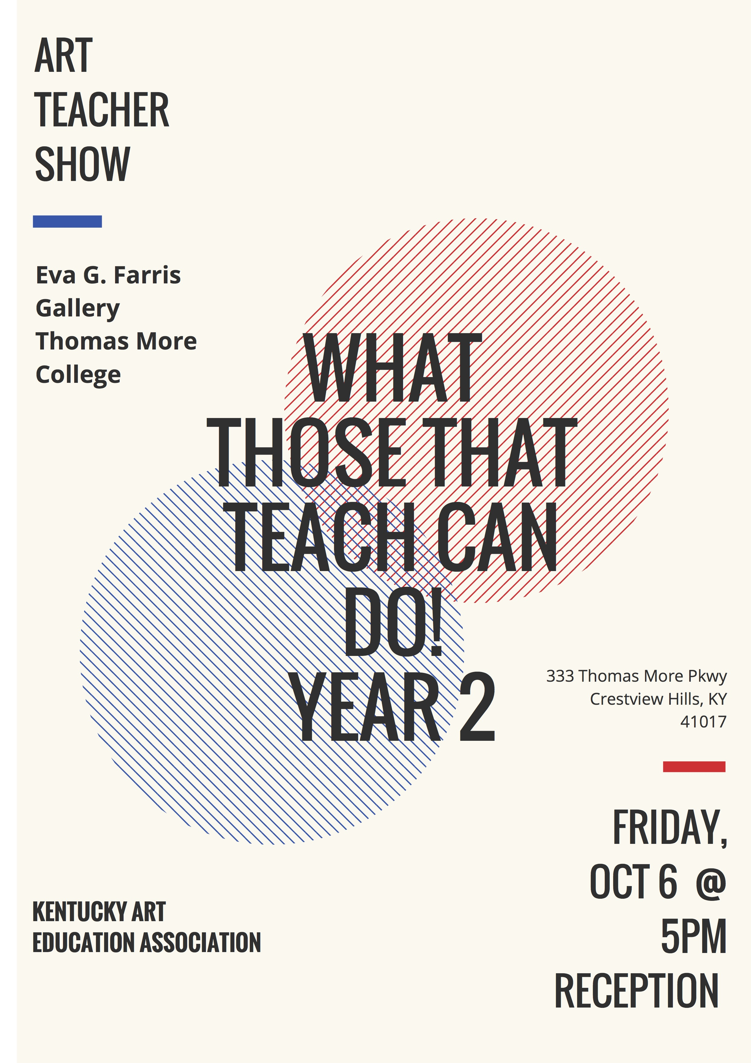
Kentucky Art Education Association
Fall Conference
October 6th and 7th 2017

Your Board

Executive Committee
President: Miles Johnson

President Elect: Ilona Szekely

Incoming President Elect: Marilyn Peters

Regional Director: Jennifer Sims
Secretary: Karen Edwards

Treasurer: Jennifer Billings

Membership: Alex Fletcher Bustetter

Public Relations: Rachael Burriss

Past Presidents: Kim Soule

Kimberly Newton

Judi Haynes

Michelle Lustenberg

Lisa Jameson

Emma Perkins

Julie Alsip Bucknam

Divisional Committee Chairs

Higher Education: Rebecca Williams

Secondary:

Middle: Tara Luster

Elementary: Staci Goggins

Retired: Susan Lackey

Supervision/Administration: Melisa Gano

Museum Education: Susan Hawkins

Private School: Jody Jaques

Student: Rebecca Williams

Regional Coordinators

Bluegrass: Kim Lee Hamilton

Burley Coal: Susan Hawkins

Caveland: Sarah Vetter

Derby: Sarah Balbach

Northern:
Pennyrile Purchase: Heather Duffy

Member At Large: Miranda Meeks
Er

Standing Committee Chairs

Program Review/Art Standards: Melisa Gano

High School All-State Coordinator: Rachael Burriss

-Northern Region All-State: Julie Harwood

-Derby Region All-State: Melisa Gano

-Caveland Region All-State: Jennifer Sims

-Pennyrile Region All-State: Heather Duffy

-Burley Coal Region All-State: Jean Petsch

-Bluegrass Region All-State: Ilona Szekely

Elementary/Middle All-State Coordinator: Tara Luster & Staci Goggins

Conference Awards: Jennifer Baldwin

Youth Art Month Coordinator: Rebecca Banks

Historian: Christy Matthews

Student Chapters Chair: Rebecca Williams

Conference Coordinator: Ilona Szekely

Mini Grants: Jennifer Billings

Scholarship Coordinator: Rebecca Williams

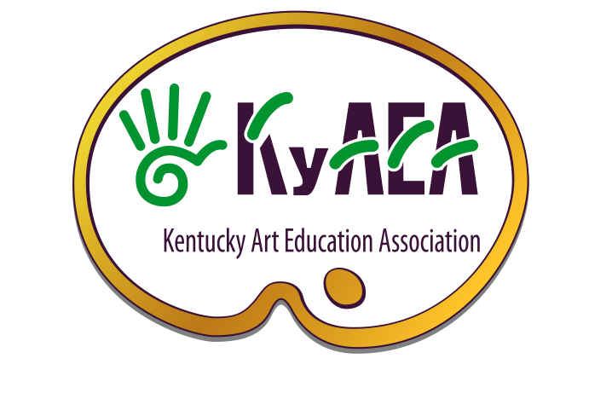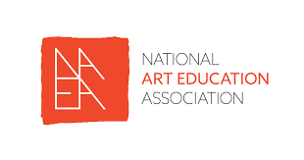

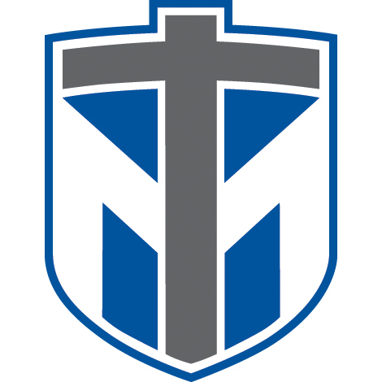

Keynote: Friday

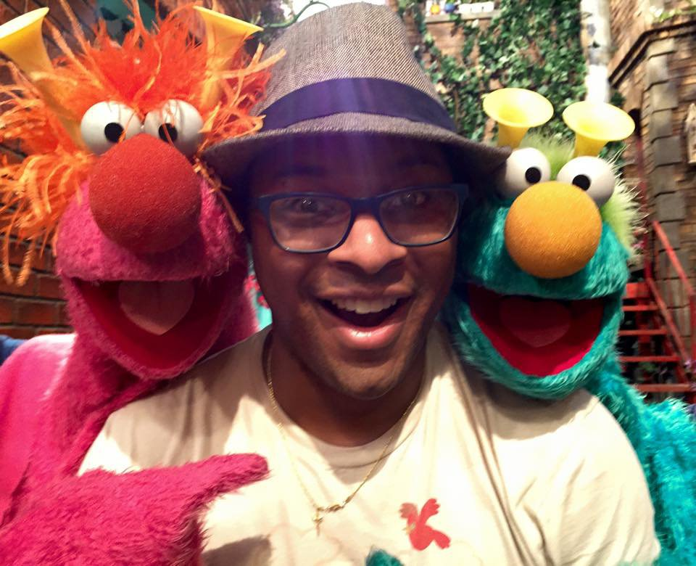

Chris Thomas Hayes is an actor, writer, director and puppeteer, from Hartford, CT.

On stage, Chris has had the pleasure to tour and perform with The Madcap Puppets, Dark Side of The Room, Whole World Theatre, and The Center for Puppetry Arts.

Chris' film and television credits include Teen Wolf,Vampire Diaries, Your Pretty Face is Going to Hell, Magic the Gathering: The Musical, and Sesame Street. He received his B.A. from Berea College. He lives in Atlanta, GA with his wife, son and dog.

Keynote: Saturday

The board members of KyAEA are EXCITED to announce that Cassie Stephens, the elementary-art-teacher-extraordinaire, will be our Saturday keynote speaker at the 2017 Fall Conference!

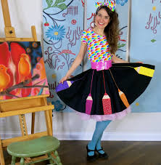

After spending entirely too long at Indiana University getting her degree in both painting and art education, Cassie Stephens did her student teaching in the magical land of Ireland. While she was away, her parents, fully aware of her slacker ways, sent out 52 art teacherin’ job applications to such far away places as Alaska. One such place that called her for an interview was Nashville, Tennessee. On a whim, she loaded up her jean-jumpers, resume and chain-smoking grandma to make the trip to Nashville where she landed her first teaching gig.

Fast forward nearly 15 years and Cassie had settled down with her husband and their three cats. Sadly, she’d fallen into an art teacherin’ slump rehashing stale art lessons, still wearing those sad jean jumpers and doing little creating of her own. It was then that she decided to create a blog that might help snap her out of her funk. Her idea was this: if she were to write thrice weekly about her ensembles, her lessons and her creations then she’d be forced to inject more creativity into her life.

Zip forward once more to the present. These days, you can find Cassie teaching in Franklin, Tennessee, just south of Nashville. Cassie has maintained her blog for the last four years. Since then, she’s managed to find the secret to her personal art teacherin’ happiness by connecting the passions in her life: teaching, creating and dressing like a crazy person. Such has helped her connect with a world of art teacherin’ friends who are also passionate about this most amazing and incredible job.

Friday, October 6th
Any session requiring a fee should be paid directly to the presenter at the time of the workshop. Please be courteous of cap sizes. Please sign up early at registration. Presenter may have brought a limited amount of materials.

7: 30 am Check in – Foyer Stigenwald – Network with colleagues

8:00-10am Room: 3109
2 hours
$5
Painting Techniques Acrylic/Tempera
This hands-on workshop will delve into exploring these commonly used paints to create effective studio projects in the classroom. Participants will explore a variety of methods of using both tempera and acrylic paint in the classroom and in their own works. Alternative techniques, supports and mediums will be experienced
Presenter: Marilyn Peters

8:00-10am Room: 3106
Exploring the Possibilities with Gelli Arts
Cap 20
2 hours
All Audiences
Learn basic concepts about monoprinting with Gelli Arts plates. Expand the possibilities of printing with Gelli plates by using stencils, adding ink without a brayer and shipping tape transfers. Your only limitation with Gelli Arts is your imagination.
Presenter: Jennifer Sims

8:00-8:40
Paper Cuts: Creative paper projects on a Dime L316
All audiences
Give your students a creativity ‘re-boot’ with a simple cartoon character drawing project based on symmetry. Also learn a fast fun way to incorporate Papel Picado for Dia de Los Muertos this Fall. In addition learn a fast an fun way to incorporate some radial symmetry into your drawing projects.
Presenter:Heather Duffey

8:45-9:40 am Room L317
Side by Side: Experiential Learning for Teacher Candidates and Students with Special Needs
55min
All Audiences
Learn about how a VSA Kentucky Side-By-Side grant was used to provide experiential learning for a group of teacher candidates and students with disabilities. The session will begin with an introduction to the grant and an overview of how the teacher candidates learned about curriculum design and differentiating instruction by developing the curriculum for our four-week program. Then the teacher candidates will give a summary of the three lessons in our unit, Playfully Visualizing Music, and provide examples of the work produced during the lessons. Lastly, we will reflect on how this hands-on experience impacted our understanding of designing thematic instruction and teaching students with disabilities.
Presenters: Rebecca Williams, Carly Duthsuk, Hailey Church, Casey Hill, Kimberly Kinsland

8:45-9:40 am Room 330S Mac Lab
Digital Photography Lesson Kit
55 min
All Audiences
Cap 12
In this session, participants will discover the essentials of implementing digital photography into their classroom or will have a way to improve their own personal photography knowledge.
Presenter: Rachael Burriss
workshop editing videos will be for sale at $5 each

8:45-9:40 am Room L315
Inclusive Art through Fundraising and Community Partnerships
55min
All Audiences
This presentation will focus on the step by step development of large fundraising events and ways to reach out to the community with your student’s art. The presentation will focus on Easter Seals WKY’s annual “HeArt and Soul art celebration and auction” which raised over $13,000 for our art program. Because the artist’s at Easter Seals WKY are also individuals with disabilities, the presentation will focus on collaborative and inclusive art lessons as well.
Presenter: Anthony Woodruff

8:45-9:40 L316
Integration of Literacy and Traveling Murals
Cap 20
55 min
Ele-Secondary
This presentation will be about combining poetry from Kentucky poet George Ella Lyon’s I am From poem with a traveling mural. See how my students create beautiful poems about our country and then created a traveling mural that incorporated their favorite parts visually. After completion, the mural and poems were on display at different locations throughout the country. This presentation comes with a FREE LESSON PLAN, handouts, and information for teachers on how to incorporate this lesson in their own classroom.
Presenter-Rachel Miller

10:00-11:20 am Keynote

Vendors and Artisans in Gallery open 11:30-3pm Friday

11: 30-12:25 pm Room L317
Student Chapter Roundtables
55min
All Audiences
The "Student Chapter Roundtables" is an annual session at KyAEA that recognizes excellence in our pre-service art education community and provides an opportunity for these students to present amongst their peers. Join our undergraduate and graduate students during this rotating session and learn about topics such as their research interests, engaging uses of technology, after-school programs, service projects, successful lesson plans, and more!
Presenter: Rebecca Williams

11:30-12:25 pm Room 330S Mac Lab
Beginners Adobe Photoshop
Cap 12
55min
Secondary
Have fun learning and reviewing Photoshop main tools in CC17. Learn how to select objects, blend images, work with clipping masks and much more!
Notes and handouts will be given as well to help remember what was learned.
Presenter: Shannon McCarthy

11:30-12:25 pm Room L315
No Fear – Start Your Own Art Business
55min
All Audiences
Yes you can start your own art business! Etsy? Shopify? Storefront? Art Lessons? Taxes? Business License? After more than 20 years of owning my own business and becoming a partner in a potter studio, I have learned a few things. Come, learn from my mistakes and successes, ask questions and share.
Presenter: Jody Jacques

11:30-12:25 pm Room L316
Robert Duncan
All Audiences
Meet with Kentucky Department of Education Visual and Performing Arts Consultant Robert Duncan for the most up to date information on the arts in Kentucky.

12:30-1:30 pm Lunch - Panera
Meet with your Regions - Check KyAEA State Map
Bluegrass, Room
Caveland, Room
Northern, Room
Derby, Room
Burley Coal, Room
Pennyrile Purchase, Room

1:35-2:30 Room 3106
Wonderful World of Weaving:
$5 fee
Cap 20
55min
All Audiences
Cassie Stephens has taught weaving to her kindergarten through fourth grade students for nearly 20 years. Learn lessons that start in kindergarten and scaffold each year until students are able to successfully create a woven pouch and cord handle. In this workshop, you'll learn several new weaving techniques and projects that you'll immediately be able to take back to your students. Weaving is a wonderful way to reach all of your students and also incorporate science, literature, geography and math. Let's get our kids weaving!
Presenter: Cassie Stephens (Saturday keynote)

1:35-2:30 Room L315
Why Steam Matters
Cap 15
55min
All Audiences
Come participate in group activities and prompts that demonstrate the importance of visualizing, communicating and conveying ideas through the use of art. See how art concepts from the elements of design to basic sketching impact and supplement the STEM courses.
Presenter: Samantha Gaier

1:35-3:35 pm Room 3109
2 hours
Audience
Hands Up! A Teppy Top Puppet Workshop (from our Fri keynote)

Join us for a workshop that will not only tackle the artistry of on camera and on stage puppetry, but will also show its very practical and historically tested ties to Social and Emotional Learning (SEL) within the classroom. Learn some puppetry to take back into your classrooms, but more importantly, have some FUN and step into the fuzzy, furry shoes of a puppeteer.
Presenter: Chris Hayes

1:35-3:35 pm Room 3109
Architecture Inspired Art Projects
Cap 30
2 hours
Ele-secondary
Artists and architects are more alike than you now! Learn to engage students in the design of the built environment. Participants will create classroom examples of at least 3 different architecture inspired art projects. Lesson plans including assessments and architecture related resources will be shared. This session connects to content/standards in other subject areas, including, but not limited to science, engineering, and math.
Presenter: Melisa Gano

2:35-3:30pm Mac Lab
Advanced Adobe Photoshop
55min
Secondary
Cap 12
Test your technical skills of Photoshop by taking this advance level of Photoshop. Various tools will be introduced to help get you to that next level of Photoshop knowledge. Great too for educators who took Beginners Adobe Photoshop earlier
in the day! Notes and handouts will be given as well to help remember what was learned.
Presenter: Shannon McCarthy

2:35-4:35 pm Room 3106
Intro to Needle Felting:
$5 fee
Cap 20
55min
All Audience
In this workshop, art teacher Cassie Stephens will introduce you to the wonderful world of needle felting! With wool roving and a special felting tool, you'll learn how to create beautiful masterpieces with this simple and fun process. Participants may bring articles of clothing such as sweaters or hats to felt thus creating a wearable work of art. Or felt your own small masterpiece that you can hang in your home or art room. This craft is also one that can be shared and enjoyed with your students from upper elementary and beyond.
Presenter: Cassie Stephens (Saturday keynote)

3:40-4:35 pm Room L316
STREET ART! A VSA Arts Inclusion Award 55min
All Audiences
Come learn how we taught this unit and created a huge mural like display of individual student pieces. Also, I will share how to write this and be awarded $ to bring in a cool artist!
Presenter: Kim Soule

3:40-4:35 Room 3109
Painting with Fire- Enameling in the Classroom
$10 fee
Cap 15
55min
All Audiences
Want to work with metals and glass in your classroom or just at home? Jody Jaques will be demonstrating and giving out info on how to cheaply and easily get started. You can come just for the demo for free (55 minutes) or sign up for the workshop (2 hours) where Jody Jaques will torch fire pennies for you and you can create a pair of earrings , bracelets or necklaces.
Presenter: Jody Jaques

5:00-6:30 pm Gala Celebration
Gallery
Awards, food, and great art!

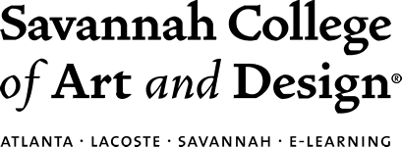^{t}

Saturday, October 7th

8:00 am Check in – Foyer – Network with colleagues

8:30-8:55
Sketchbook Marathon—Using Sketchbooks Effectively
25min
All Audiences
Bring your sketchbook and join us for doing a marathon of sketchbook activities. This will be a hands-on workshop so prepare to use the conference sketchbook onsite. Ideas on how to use sketchbooks in your classroom and what to have students do in the sketchbook will be provided.
Presenter: Marilyn Peters

9:00-10:00 am Keynote Stigerwald
Cassie Stephens

Vendors and Artisans in Gallery open 10:00-2pm Saturday in Steigerwald

10:05-11:00 am Room L315
Higher Education Summit
55min
Higher Ed
The "Higher Education Summit" is an annual session at KyAEA that provides an opportunity for higher education teachers and administrators to connect. In the session we will learn about each other’s activities, discuss happenings in the field, and project future aims of the division.
Presenter: Rebecca Williams

10:05-11am MacLab 330S
Stop Motion Animation and Art
55min
All Audiences
Cap 12
Are you interested in using technology in the classroom, and helping students use their art skills to create original short stop motion animation films? I will share some of my experiences with you, and we will do some hands-on exploration of the technology and art involved.
Presenter: Karen Edwards

10:05-11:00 am Room L316
About Brushes (Royal & Langnickel Brush)
55min
All Audience
Seminar Description (to be printed in booklet): Are you overwhelmed when you look at all the different brush options? In this workshop, you’ll get a set of brushes to follow along as we discuss different hair types, handles, shapes and sizes and best uses. We’ll also cover brush care practices and things you can do before, during and after using the brushes to make them last longer. We’ll also show how to use each shape and answer

your brush questions. Each participant receives a set of brushes to keep.
Presenter: Michael Harbridge

10:05-12:05 am Room 3109
Dream Rocket: The Printed Quilt!
$10 fee
Cap 20
55min
All Audiences
Explore how the Dream Rocket Project has broadened my printmaking processes to fabric. Learn how to print on fabric to create pieces that your students can sew into a quilt. Printmaking processes that will be explored will include: monoprints with Gelli plates, Gyotaku prints with embellishments, cyanotype (sun prints) on fabric and block printing on iron-on transfers with watercolor pencils.
Presenter: Jennifer Sims

12:05-1:15 pm Lunch – Panera
Meet with your grade level:
Elementary, Room
Middle, Room
High School, Room
Museum/Higher Ed, Room

Silent Auction Ends at 1:15 pm

1:20-2:50 pm Room L317
Developing a High Quality High School Visual Arts Program
Cap 30
90 min
Secondary
Whether you are new or a veteran to teaching high school visual arts, learn different approaches to “defining” and improving your high school visual arts program. Starting from scratch? Need to tweak what you have? Schedules, sequencing courses, curriculum planning processes, syllabi, funding, budgeting, partnerships/collaborations, portfolio development, student participation in visual arts competitions/exhibitions/events, and more will be shared!
Presenter: Melisa Gano

1:20-3:20 Room 3106
Weaving for Beginnings
$25 fee
Cap 20
2 hours
All Audiences
In this session, participants will learn and practice beginning weaving techniques with yarn and mixed media, and leave with several examples and resources ready for use in the classroom on Monday! Elementary and Middle levels will be the primary focus, however, basic weaving skills are also useful/appropriate for the Secondary Level as well. A materials fee is due to the presenter at the beginning of the session.
Presenter: Julie Bucknam

1:20-3:20 Room 3109
Watercolor Techniques for the Classroom and Artist
Cap 20
This hands-on workshop will delve into creating using watercolor. Participants will utilize effective practices in watercolor painting and explore some lesser used techniques to create a finished work. The presenter will share how she has used watercolor in the classroom with students from elementary to secondary level.
Presenter: Marilyn Peters

2:20-3:15 pm Room L316
Maker Space in the Art Room!
55min
All Audiences
We just installed a MakerSpace in the art room and are learning as we go. 3D printing, CNC Milling machine and a Laser. Projects, ideas, websites and other info will be shared!
Presenter: Kim Soule

2:20-3:15pm Room L315
Understanding and Accessing Creativity
55min
All Audiences
What conditions, attitudes, and behaviors support creativity and innovative thinking? What factors prevent or encourage people to take creative risks? How does collaboration expand the creative process? These essential questions from the National Core Arts Standards are meant to help our students cash in on the currency of the 21st century. In this session, we will develop background knowledge about what creativity is and then work together to identify how we can both help and hinder creativity in our classrooms. Then several creativity educing strategies will be shared. These idea-generating strategies will help your students move past the fear of the blank canvas as they seek to achieve Anchor Standard 1: Generate and conceptualize artistic ideas and work.
Presenter: Rebecca Williams

2:20-3:15 pm Room L316
Artsonia: The total package for your classroom!
55min
All Audiences
Learn how to use Artsonia to assist in classroom management of student artwork and create an online portfolio. Learn how easy it is to set-up your classroom rosters and monitor your students progress. Learn how to record your curriculum using the National Standards, assessment and writing outcomes using Classroom Mode through ARTSONIA.
Presenter: Jennifer Sims

3:30 pm Final Gathering/Prizes/Goodbye!!
Atrium
Reflect on conference.
Turn in Survey.
Prizes Awarded.
Pay and Pick Up Auction Items.

