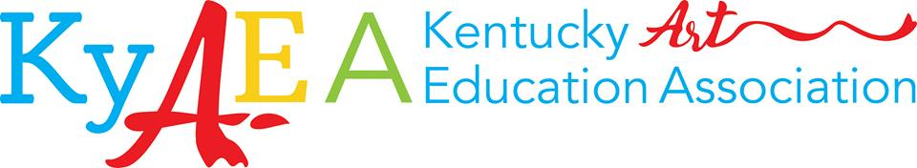

Artisan Form - Must be postmarked by September 9, 2019
Conference: Oct 11th and 12th @ Jessamine County Middle School
Artisan set up: 8:30-10:30 a.m. on Friday
Vending Times: 10:30-3:00 on Friday and 10:00-2:00 on Saturday

One (1) complimentary lunch ticket per day (Friday and Saturday), additional lunch tickets will be $10 each
Invitation to the KyAEA Awards Gala on Friday evening.
Access to visual art educators from across KY

Company Name:

Contact Name:

Address (including city, state and zip):

Email: |  |  |  | Phone: |  | Fax:
Company/Product Description:

Identify the way your donated door prize will be delivered:
Mailed or Dropped off at conference on Friday?

Description of Donated Door Prize:

#’s of Tables Needed: | Electricity Hookup Needed: No Yes |  | # of additional lunch tickets needed ($10/each)  Friday: Saturday:
Would you like to hold a hands on class? No Yes – Cap size for class:
Class Title:

Class Description (50 word limit and to be printed in booklet):

Which day(s) will you present?  Friday Saturday |  | # of times you would like to present: 1 or 2
 |  | Cost
Artisan Registration Fee |  | Free
Total Amount Enclosed
Please mail completed form and payment by September 9th 2019 to:

Make CHECKS payable to: KyAEA
Mail packages to:
Marilyn Peters
2181 Hardesty Road
Springfield, Ky 40069
Phone: 859-481-1998
Questions? Email: presidentelectkyaea@gmail.com

Hotel info: (if needed)
**Coming Soon**

